DAA LAB ACTIVITY – 5
Name: AVESH ANSARI S
Roll no: CH.SC.U4CSE24202

Merge sort:
Code:
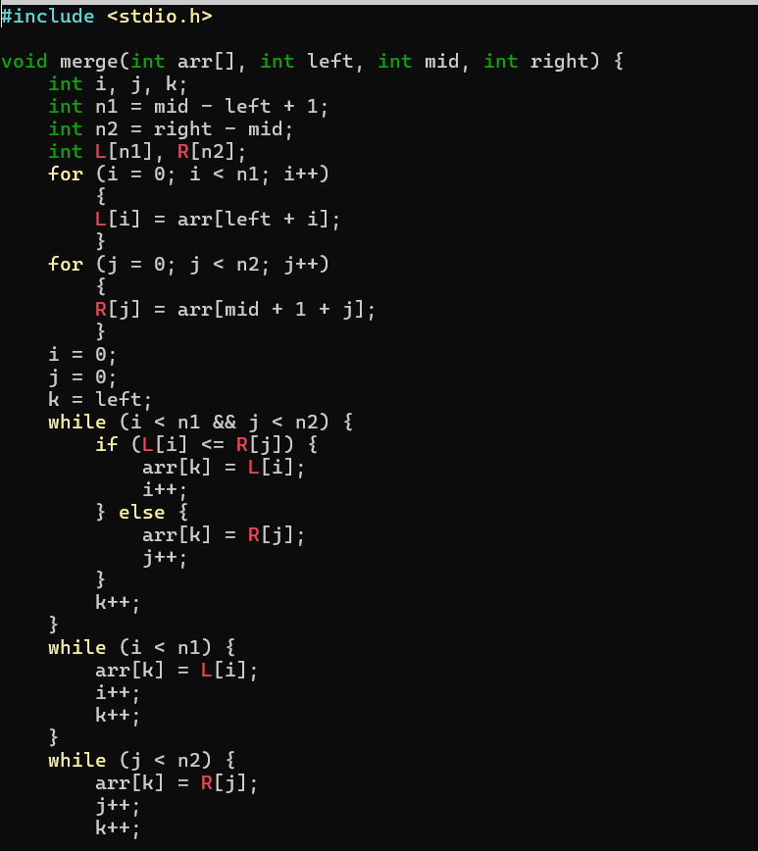
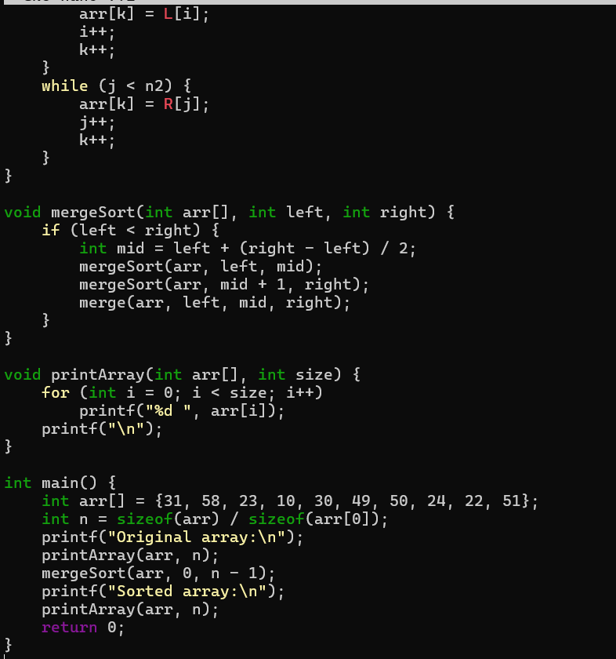
Output:
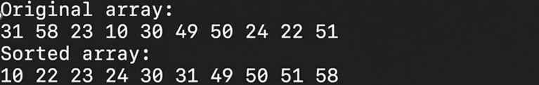

Quick sort:
Code:
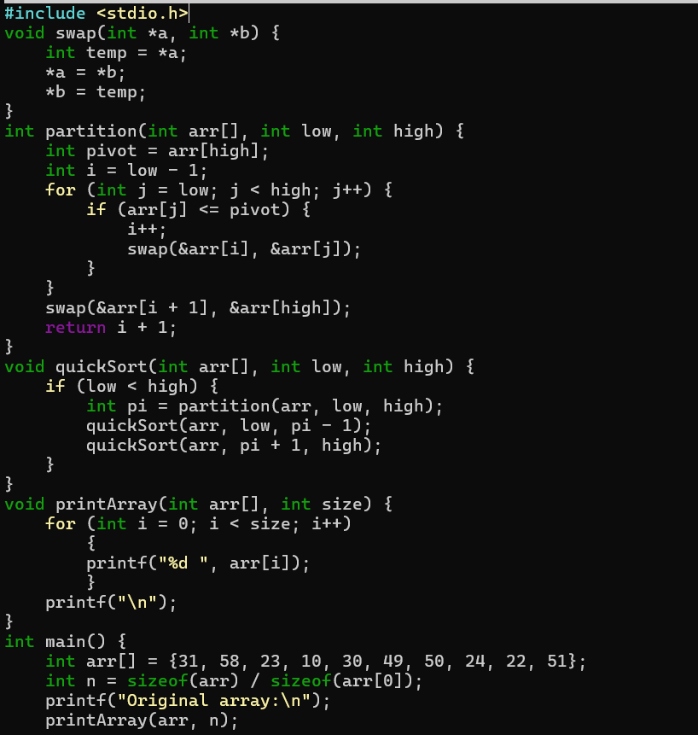
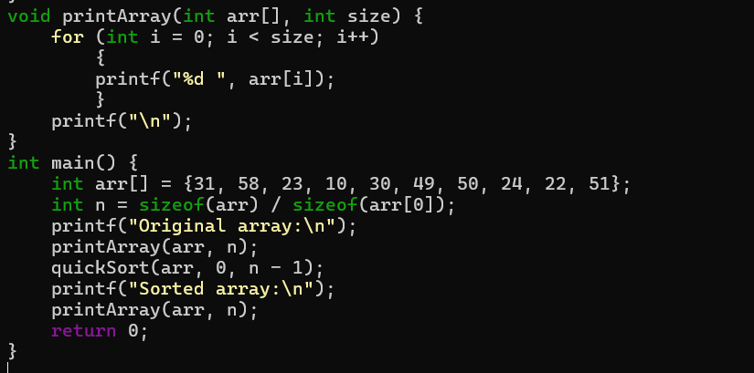Output:
